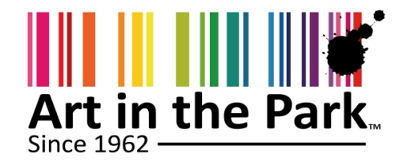
Announcing dates for 58th Art in the Park 2022
Address by D Mhlongo- Director PMB Tourism
Two years in the coronavirus pandemic, the enormous changes in our lives became unremarkable: The collection of fabric masks. Working or learning from home. Virtual meetings but most importantly limitations to recreation as outdoor activities were prohibited
Income and Lives of many artists were radically impacted on as the calendar of the art industry was disrupted.
The pressure to come out is beginning to implode throughout the world hence we have seen demonstrations for opening stadiums, and so on. As this is happening many new events are beginning to emerge to hopefully cash on the demand that exists.
As traditional event organisers are trying to recover, it feels like they are staging new events all together and sometimes this comes with unfair expectations from the audiences that they serve.

For example, I have noted recent criticism to Comrades Marathon Association after they announced 2022 Race but it seems to me that this is the only way & format that they needed adopt to save this historic race.

While the issue of Covid and lockdowns was common knowledge, we sought to keep our stakeholders informed about what was happening from the;
- Communication of cancellation of AIP 2020
- 2021 Survey on possible using level one window to stageArt in the Park in December 2021 to which the response was that many stakeholders had already planned holidays
- Communication to advise that we would revert to end April in 2022 to stage Art in the Park

We understand the impact that this has on the entire creative sector and we support vaccination campaign as means to mitigate this impact going forward.

In the past safety of a visitor destination has always been about crime and today Covid19 risks occupy the minds of all potential visitor.

Generally, it is our hope as a sector, that the continued compliance of the COVID-19 protocols and support of vaccination programs will develop greater confidence alongside the growing community immunity that should follow.

The Art in the Park festival plays an important role in the lives of many local artists besides the fact that it is a key event on the city calendar.

We are committed to delivering a high quality event that is safe, exciting and fulfilling for all our stakeholders and patrons.

As we reflect, we note the journey we have travelled, in particular the independent survey that we commissioned in 2015 whose broad recommendations were:
- Change venue
- Diversify race and age of participants in the show both of which we have responded to.
We have responded to these including positioning Art in the Park a festival which has assisted to achieve above.

One of the objectives of Art in the Park festival is to expose the artists that would otherwise never have exposure opportunity. Many artists can testify to our efforts in this regards
I wish thank Creative Arts College, our main partner and the KZN Botanical Gardens which has kept the quality of this venue to the expectations of exhibitors and patrons alike. We assure you of continued quality in the show. Further partners will be announced in due course
Now the announcement of date for 58th Art in Park (2022) as following:
KZN Botanical Gardens on 28 April – 02 May 2022
Thursday, 10am-10pm
Friday, 10am-10pm
Saturday, 10am-10pm
Sunday, 10am-10pm
Monday, 10am-4pm

Further I am happy to announce that we have partnered with National Department of Arts & Culture to structure Covid19 relief for Artists and crafters. This will mitigate stands fees to the value of 35% and will be disbursed through applications on a first come first served bases
Contact 033 3451348/9/0749603186

End/

