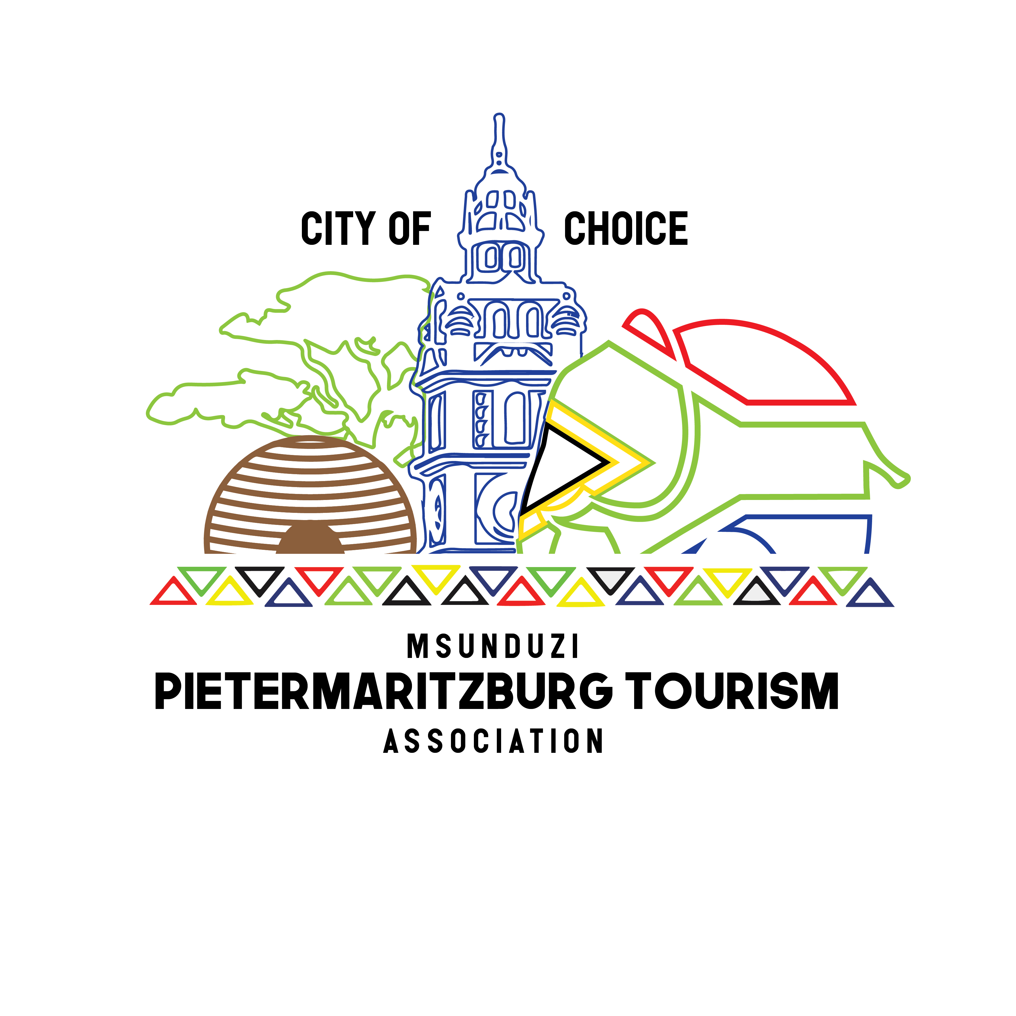
Msunduzi Pietermaritzburg Tourism Association
Publicity House
177 Chief Albert Luthuli Street
Pietermaritzburg
3200

Tel: 033 3451348 Fax: 033 3943535 E-mail: admin@pmbtourism.co.za www.pmbtourism.co.za

MEMBERSHIP APPLICATION FORM 2024/25

Vat Reg No: ______________________________

Name of Business: ___________________________________________

Type of Business: ___________________________________________

Membership category: ___________________________________________

Physical Address ___________________________________________

___________________________________________

Postal Address: ___________________________________________

___________________________________________

Code: _________________

Telephone No: __________________________ Fax No: ____________________________

Cellphone No: _______________________ E-mail: __________________________

Website: ___________________________________________

Star Graded: ___________________________________________

Contact Name: ___________________________________________

Signature: ___________________________________________

Date: _______________________

Proof/Copy of Special Consent:
Members Date of Birth:
Please tick relevant box:

Renewal New Application

Account Number: OFFICE USE ONLY
Notes & Conditions
General
- Msunduzi Pietermaritzburg Tourism Association membership runs from July – June yearly.
- Membership should be renewed every July by completing a brand new application form, notice of which is given.
- Brand new members to the organization pay a pro – rata rate when joining from September onwards.
- Existing members on renewal pay the full price.
- Cancellation of membership must be indicated by completing a cancellation form.

Tour Guides

- Required Documents.
- Tour Guiding Accredited Certificate NQF 2 or NQF 4
- Copy of Certified Identity Document

Tour Operators
- Required Documents.
- BBBEE Certificate/Business Certificate
- Department of Transport Permit
- Copy of Certified Identity Document

Accommodation Establishments – It is imperative that all 3 steps are completed

- Required Documents.
- BBBEE/Business Certificate
- Special Consent
- Copy of Certified Identity Document

STEP 1

Obtain Special Consent from Msunduzi Municipality
Contact: 3922176
5th Floor Symmons Centre
Usually takes between 3 to 4 months

They will then circulate the application for special consent to the Health Dept, who will then come to check the B&B to see if it conforms to regulations.

STEP 2 – Annual membership
Register with a local tourism authority, i.e. Msunduzi Pietermaritzburg Tourism Association
Contact: 033 3451348

STEP 3 – Annual membership
Tourism establishments are reminded that registration with Tourism KwaZulu-Natal (TKZN) has been taken over by the Department of Economic Development Tourism and Environmental Affairs (EDTEA), headquartered in Pietermaritzburg. The following points are important: the copy of the owner’s ID must be certified and seven photos of an establishment must be supplied on CD or e-mailed to nosipho.zondi@kznedtea.gov.za: Tourism product owners who have already paid their registration fees to TKZN will be accepted, but in future must be paid over to the EDTEA. Once the four-page registration form has been completed and submitted, payment must be paid and proof of payment either faxed to: 0862758378, posted to Sthembiso Nosipho Zondi at P/Bag X 9152, Pietermaritzburg, 3200 or hand delivered to 217 Burger Street, Calder House, Pietermaritzburg, 3201. Contact no: 033 2649316

According to regulations that were promulgated on 13 May 2004 under section 32(f) and (i) of the KwaZulu-Natal Tourism Authority Amendment Act, 2002, certain tourism related enterprises may voluntarily register with Tourism KwaZulu-Natal , if they have not done so already. However, in terms of these regulations registration is mandatory for enterprises whose primary object is to provide services and facilities to tourists in the province of KwaZulu-Natal.

PLEASE TICK THE BOXES THAT ARE APPLICABLE TO YOU. PLEASE CALL 033-345 1348 FOR HELP IN COMPLETING THIS FORM.
TELL US ABOUT YOUR BUSINESS

Accommodation Establishments
Please complete this section
Please supply 50 word description of your establishment for the accommodation database.

Total Number of Rooms: ____________
No of single rooms: ____________
No of double rooms: ____________
Number of twin rooms: ____________
√Self – Catering
√B&B
√Guesthouse
- Backpackers

PLEASE TICK RELEVANT CATERGORY

Rates Per Person
Self – Catering: _______________
B&B: _______________
Dorms: _______________
Single supplement: ________________
Camping: ________________
Special Group rates: _______________

√ Long-term availability
√ En-suite – bath/Shower
√Away from main house
√Air – con
√Conference facilities
Details: ___________________________

Distance from CBD ______________

Facilities offered:
√Safe undercover parking
√Tea & Coffee in room
√Bar
√Disable friendly
√Fax/Email facilities
√Pool
√TV
√MNET
√DSTV
√Dinner available
√Laundry
√Tennis court
√Credit card facilities
√Pets allowed

Restaurants & Food Establishments
PLEASE TICK RELEVANT CATEGORIES
Number of seats: _______________
Bar
Secure parking
Breakfast
Lunch
Dinner
Live entertainment
A-la Carte menu
Buffet
Specialty Details: _________________________________

Clubs & Societies

Chairman’s Name: ___________________

Date & Time of meetings:
__________________________________

Meeting venue: ____________________

Type of club: ____________________

Corporate Companies

Product type: ______________________

Nature of business: _________________

Tour guides

Area of service: ____________________

Own vehicle: _____________________

Max pax: ______________________

Languages: _______________________

Certificates & Licenses: _________________
_____________________________________

Tour Operators & Car Rentals

Area of service: ____________________

Type of vehicle: _____________________

Max pax: ______________________

Languages: _______________________

Licenses/Dept of Transport Permit: ___________________________________

Membership | Membership Category | Benefits
Business Type | All accommodation establishments & Restaurants | - Membership Certificate  - Voting Rights at the AGM  - Monthly Newsletter  - Brochures displayed at the Publicity  House.  - Listing in Tourism Directory on the  website with contact details  - Regular updates on “What’s On” in  Pietermaritzburg | R550.00
Business Type | Transportation:  Car Rentals, Tour Operators, | - Membership Certificate  - Voting Rights at the AGM  - Monthly Newsletter  - Brochures displayed at the Publicity  House.  - Listing in Tourism Directory on the  website with contact details  - Regular updates on “What’s On” in  Pietermaritzburg | R550.00
Business Type | All Tourism Attractions:  Museums  Parks  Etc. | - Membership Certificate  - Voting Rights at the AGM  - Monthly Newsletter  - Brochures displayed at the Publicity  House.  - Listing in Tourism Directory on the  website with contact details  - Regular updates on “What’s On” in Pietermaritzburg | R550.00
Business Type | All Emerging Tourism Business:  Tour Guides | - Membership Certificate  - Voting Rights at the AGM  - Monthly Newsletter  - Brochures displayed at the Publicity  House.  - Listing in Tourism Directory on the  website with contact details  - Regular updates on “What’s On” in Pietermaritzburg | R300.00
Business Type | Schools , Clubs & Societies ,  NGO’s | - Membership Certificate  - Voting Rights at the AGM  - Monthly Newsletter  - Brochures displayed at the Publicity  House.  - Listing in Tourism Directory on the  website with contact details  - Regular updates on “What’s On” in Pietermaritzburg | R300.00
Business Type | Individuals Members | - Membership Certificate  - Voting Rights at the AGM  - Monthly Newsletter  - Regular updates on “What’s On” in  Pietermaritzburg | R100
Business Type | Youth – Individuals under 25 years of age | - Membership Certificate  - Voting Rights at the AGM  - Monthly Newsletter  - Regular updates on “What’s On” in  - Pietermaritzburg | R50

Banking Details:
Account Name: Msunduzi Pietermaritzburg Tourism Association
Standard Bank Pietermaritzburg
Acc No: 25 75 92105
Branch code: 057525

